Measurement Test Study Guide

- Instrument used for measuring mass triple beam balance
- amount of space an object occupies volume
- temperature scale used in the metric system Celsius
- an object’s mass divided by its volume density
- Instrument used to measure the volume of liquids and irregularly shaped objects graduated cylinder
- unit of mass in the metric system gram
- unit of volume used in the metric system liter
- measure of gravitational pull on an object weight
- amount of matter in an object mass
- unit of length used in the metric system meter

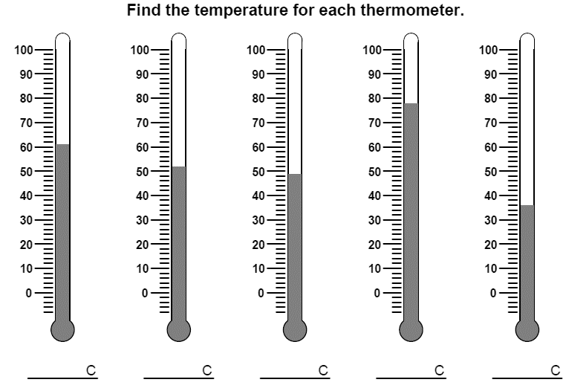
36º
78º
49º
52º
61º

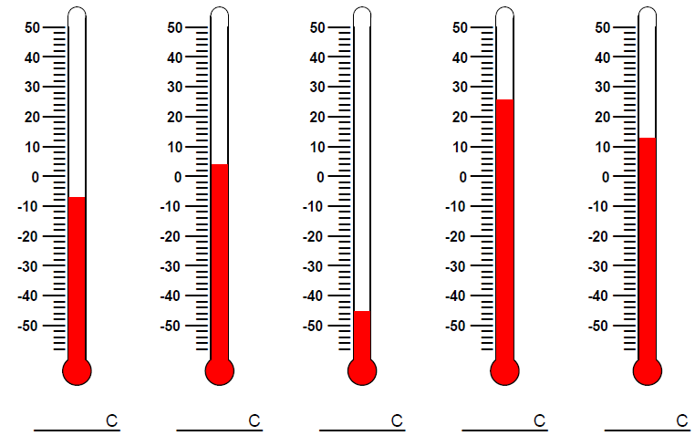
13º
26º
-45º
4º
-7º
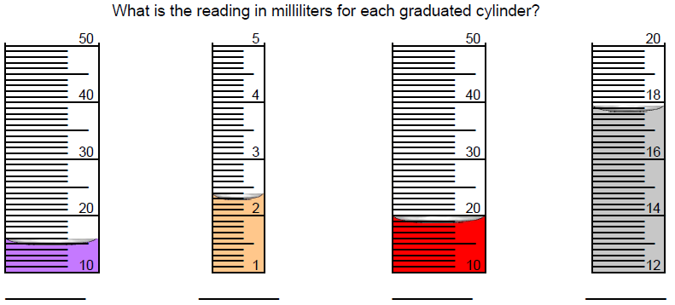
17.8 ml
19 ml
2.3 ml
14 ml

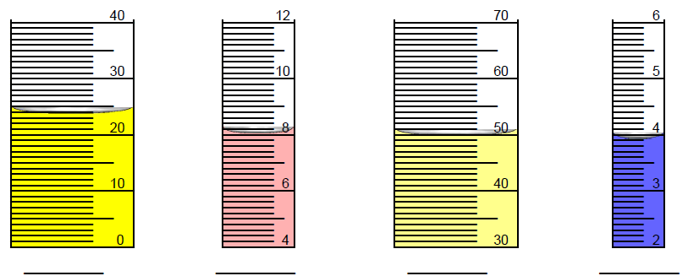
4 ml
50 ml
8 ml
24 ml

Read the triple beam balance and record the mass.
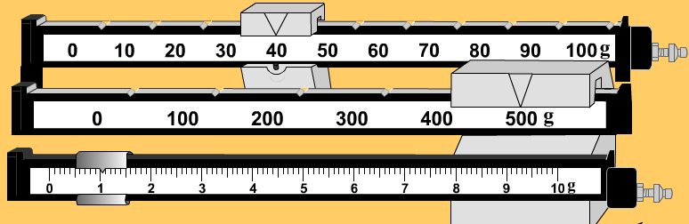 _____________
541 g

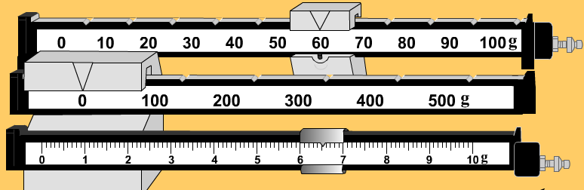 _____________
66.5 g

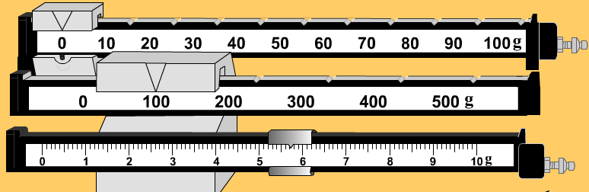_____________
105.7 g

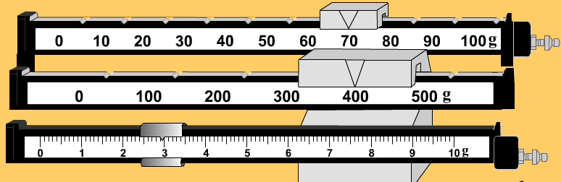 ______________
472.9 g

MASS | VOLUME | DENSITY | Will this item sink or float in water?
5.02 g | 6.10 mL | .823 g/ml | float
1.0235 g | .2589 mL | 3.953 g/ml | sink
.3025 g | 25.01 mL | 0.0121 g/ml | float
8.89 g | 3.254 mL | 2.732 g/ml | sink
215.7 g | .15369 mL | 1403.47 g/ml | sink

Solve the word problems.
A block of wood has a mass of 280 grams. It is 10.0 cm long,
6.0 cm wide, and 2.0 cm thick. What is its density? 2.33 g/cm³

A bar of gold has a mass of 281.9 grams and a volume of 11 ml. What is its density? 25.63 g/ml

A rock raises the water in a cylinder from 20 ml to 40 ml. It has a mass of 6.5 grams. What is its density? 0.325 g/ml

