Mrs. Runyans’ Science Class
What do you need to bring?
- Science notebook
- Pencil
- Paper
- Agenda
How will you be graded?
- Daily assignments and quizzes – 80%
- Tests – 20%
Classroom Expectations
- Follow all school rules
- Be respectful to fellow classmates and teacher
- Always be prepared
- Come in to the room quietly
- Copy your objectives and homework assignment as soon as you sit down
- Clean up after yourself
- Do homework if it is assigned
If these expectations are not met, then you may receive a discipline slip.
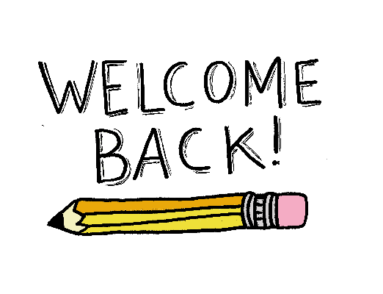
E-mail – mrunyans@spartanburg4.org
Phone – 476-3150 ext. 3528

