NAME ____________________________

- What is the most basic living or structural unit of all life?_____________________

- Which cell structure is responsible for coordinating cell activities and is also responsible for reproduction?____________________________________

- Which structure allows materials to enter and leave the cell? __________________

- Diffusion is when molecules ________________________________.

- All living things are made of ______________________.

- What is the clear, jelly-like substance that is found inside plant and animal cells called?______________________________________

- What is a plant cell structure in which food is made? _______________________

- The part of plant cells that is normally green is the_________________.

- What component of a cell serves as a temporary storage center?________________

- The diffusion of water across a membrane from an area of higher concentration to an area of lower concentration is called ________________________

- Plant cells have chloroplast and a _________________ that animal cells do not.

- What part of the cell does photosynthesis occur in? ________________________

- Which structure that serves as the cell information center can be found in both plant and animal cells?_________________________

- Why are vacuoles smaller in animal cells than in plant cells? ________________________________________________________________
- Which structures provide shape to plant cells and allow plants to store food and water?______________________________________

- Which picture shows a plant cell?
  - 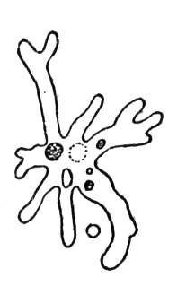 B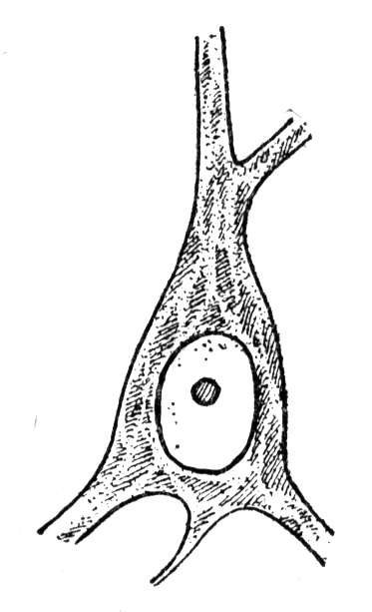 C 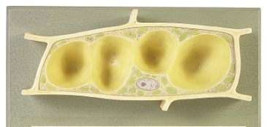 D

- List the two organelles you would expect to find only in a plant cell?
________________________________

- What type of bacteria has a spherical or rounded shape? ___________________

- True or false – Protists are classified in the animal kingdom? _______________

- How are the euglena different from other protists? ________________________________________________________________

- What is the foot like structure that allows some protists to move by being extended forward and then pulling the body forward as well?________________________

- What structure is used by the Euglena to move and pull themselves around? __________________________

- List the three types of protists. _______________________________________________________________

- What body structure helps the paramecium move through water?
________________________________

- Rod shaped bacteria are also known as __________________________

- What term is used to define the ability of an organism to keep conditions inside its body constant, even though conditions in its external environment may change? _________________________________________________

- What process converts light energy to chemical energy that is then stored in sugars?

________________________________________

- What cellular process is needed for growth, replacement, and asexual reproduction?

_________________________________________

- Which individual is best known for his work in the field of heredity or genetics?__________________________ (he studied pea plants)

- What is a trait that is the “weaker” of two traits called? _____________________

- Any trait that can be observed in an organism, such as a structure or a particular function, is part of the organism’s ________________________________.

- The internal stored information (two letters) that deals with all aspects of the heredity of an organism is called its _________________________________.

- An allele is represented by Hh. Does the H represent the dominant or recessive trait?______________________________

- Any one of several alternate forms of a gene, the letter that occupies a given position on a chromosome, is called a/an ___________________________.

- Each species of organism has a characteristic number of these. For example, cats have 19 pairs, for a total of 38. What are being described? _________________________

- ____________________________ are strands of tightly woven DNA.

- The Punnett squares below show the results of mating peas that have traits for a round shape or a wrinkled shape.
The gene for the round shape is dominant.
Generation 1: Both parents purebred |  | R | R
 | r | Rr | Rr
 | r | Rr | Rr
In the first generation, what portion of the peas is rounded? ______________

- When using Punnett squares to show inherited probability, what does a capital letter stand for?__________________________

- When purebred tall plants are crossed with hybrid tall plants, what will the offspring look like?________________________
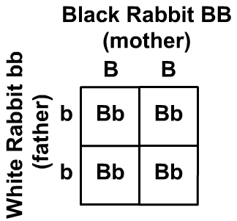

This Punnett Square shows the genetic cross between a black and a white rabbit. Use this diagram below to answer the next 2 questions.

- In the purebred black rabbit, what term is used when the two alleles are BB? _________________

- Would the first generation offspring of a white rabbit and a black rabbit be heterozygous or homozygous?
____________________________________

- List the three types of mutations, ___________________________________________________

- Two hybrid fruit flies each have a dominant gene for brown eyes (B) and a recessive gene for red eyes (b). They are mated. What percent of the offspring have brown eyes? ______________________

- In squirrels, the gray fur gene (G) is dominant and the gene for black fur (g) is recessive. If 50% of a squirrel litter is black, what parental cross probably produced this result? ___________________________________

- If “S” stands for a dominant form of the “smooth” gene in a plant (producing smooth leaves), and “s” stands for a recessive form of the “smooth” gene (producing wrinkled leaves), what gene structure would a hybrid plant have? __________________________________

- Each row and column in a Punnett square is labeled with a letter. What does each letter (allele) stand for?______________________________________

